**AI LAB 4.1**

**Task 1: write a python program to generate a function that validates an indian mobile number.**

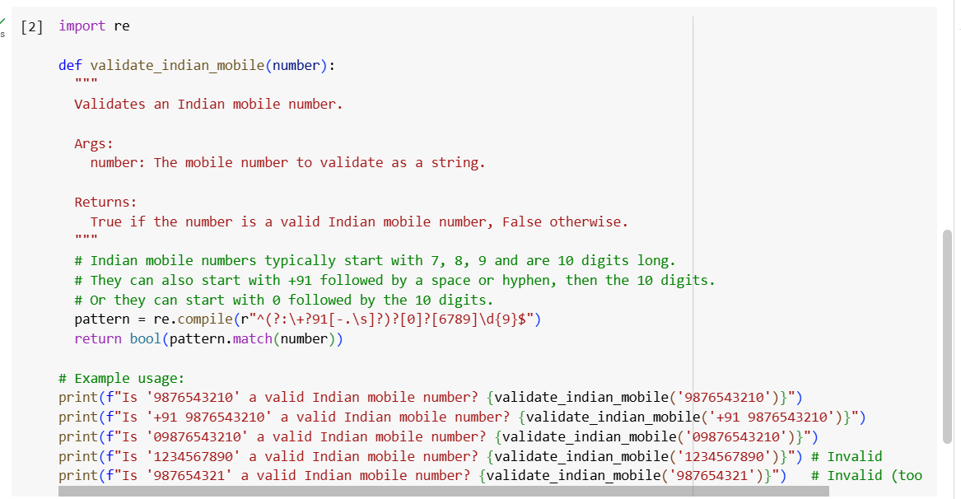

**Output:**

**Explanation:**

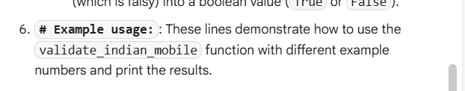

**Task 2: write a python program that calculates factorial of a number.**

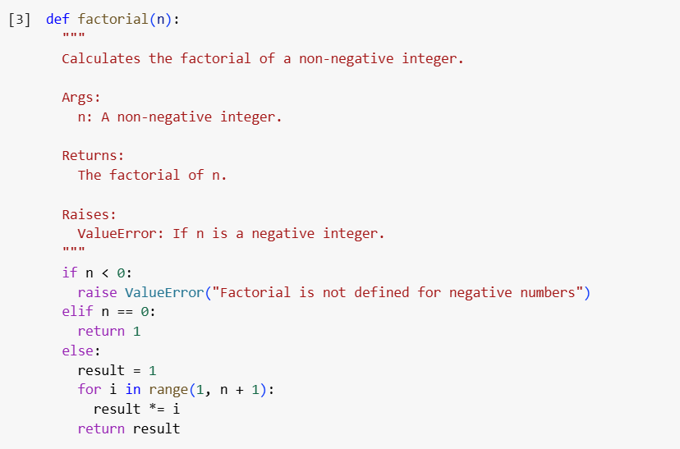

**Output:**

**Explanation:**

**Task 3: {John Doe , Computer Science,8.5},{ nithya,ece,9.3},{rahithya,mechanical,9.3} with this examples write a python program using functions to extract and return Full Name Branch SGP.**

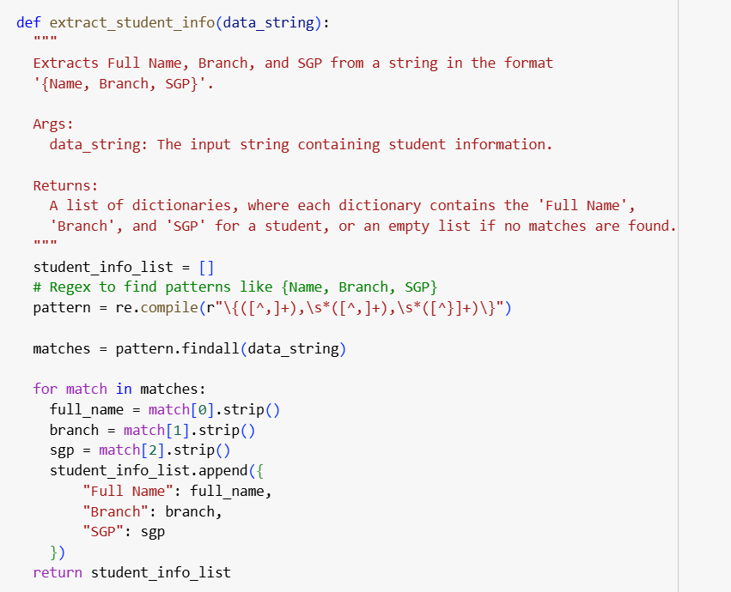

**Output:**

**Explanation:**

**Task 4:**